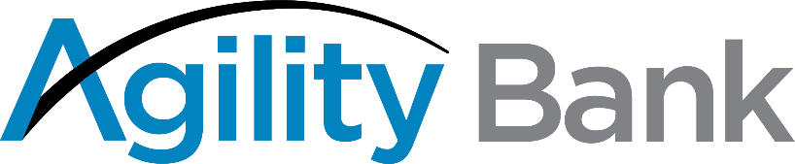

Trustmark National Bank and Agility Bank (in organization) Enter Strategic Collaboration Agreement

Houston, TX and Jackson, MS – January 25, 2022 – Trustmark National Bank, a wholly-owned subsidiary of Trustmark Corporation (NASDAQGS:TRMK) and Agility Bank (in organization) are pleased to announce that the companies have entered a strategic collaboration agreement to highlight the strengths and deepen the community commitment of both banks as part of the Project REACh Initiative with the Office of the Comptroller of the Currency.

The Project REACh Initiative, standing for Roundtable for Economic Access and Change, encourages meaningful partnerships to assist minority-owned banks to be important financial resources in their communities and a vibrant part of the economic landscape. Agility Bank (in organization) will be the first primarily women-owned and led Minority Depository Institution (MDI) organized for this purpose in the U.S.

“This is truly a unique opportunity to reach deeper into the areas we serve to meet the growing needs of women and all minority business owners,” said Duane Dewey, Trustmark President and CEO. “Women-owned businesses are growing at twice the rate of all businesses nationwide, and we are committed to supporting this growth.”

Trustmark will share educational and marketing activities in local communities to ensure more information is put into the hands of those who have developed businesses and those who aspire to become business owners. In addition to an equity investment in Agility, Trustmark also will share in loan participations and deposits, as well as provide access to its comprehensive range of personal and business banking services.

“We are particularly excited about this relationship with Trustmark given its history in its communities and the opportunities to support women and minority-owned businesses,” noted Lauren Sparks, Founder, Chair and CEO of Agility Bank (in organization). “The growth of these companies is key to the continued success of our communities.”

“The collaboration between Trustmark and Agility Bank is an excellent way to highlight our continued commitment to women and minorities who have formed companies that greatly support the economy,” said Dewey.

About Trustmark:

Trustmark Corporation is a diversified financial services company headquartered in Jackson, Mississippi, with 180 locations in Alabama, Florida, Mississippi, Tennessee, and Texas. Trustmark provides banking, wealth management and insurance solutions through its subsidiaries, including Trustmark National Bank, Trustmark Investment Advisors, Inc., and FBBINSURANCE. Visit trustmark.com for more information.

About Agility Bank (in organization)

Agility Bank (in organization) is the first primarily women-owned and led bank created for this purpose in the U.S. under a special Minority Depository Institution national charter of the Office of the Comptroller of the Currency. With a focus on community business banking, the bank will serve all small and mid-size business owners. Houston-based Agility will provide a flexible digital-based platform that is as close to a fintech banking experience as business owners need or want. Coupled with the knowledge of savvy bankers, clients will have access to personal service powered by robust technology. For more information: www.agilitybanking.com

Media Contacts:

Melanie Morgan
Trustmark
Director of Corporate Communications & Marketing
601.208.2979
mmorgan@trustmark.com

Sarah Peterson
Director of Marketing and Community Outreach
Agility Bank (in organization)
713-702-4470 (cell)
sarah@agilitybanking.com

